**Dashboard and visualization on weather Analysis using Tableau**

The Weather Analysis Dashboard empowers users with actionable insights derived from comprehensive weather data analysis. By leveraging interactive visualizations and advanced analytics, stakeholders can better understand weather patterns, anticipate future trends, and make informed decisions to optimize various aspects of their operations. Whether it's agriculture, transportation, construction, or any other industry impacted by weather conditions, this dashboard serves as a valuable tool for maximizing efficiency, minimizing risks, and achieving strategic objectives.

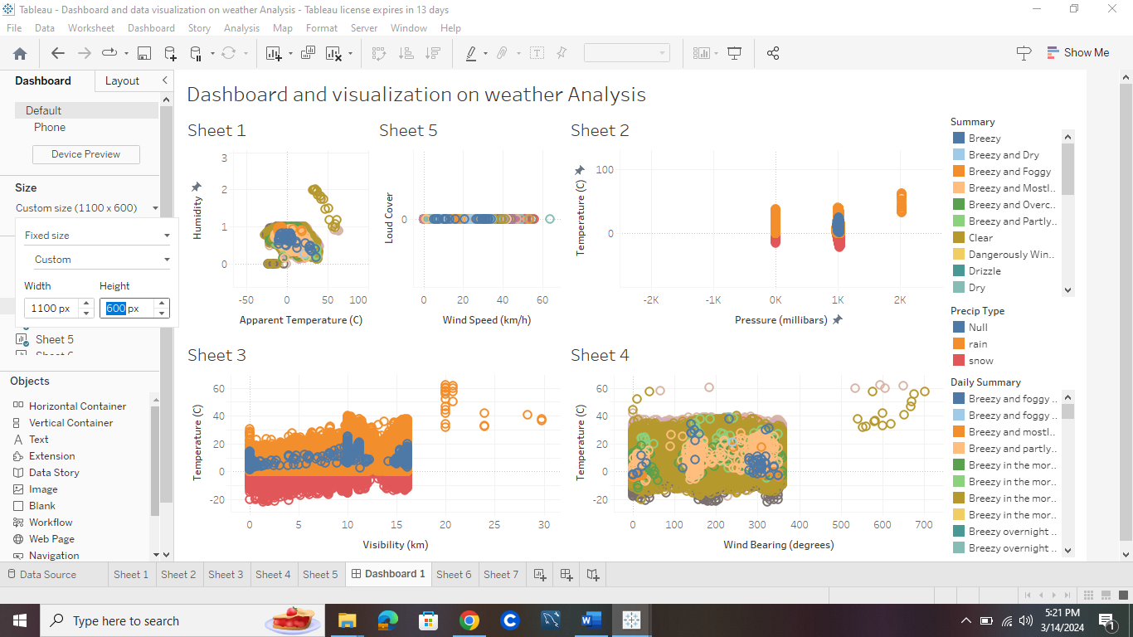

* In this dashboard, it is Representing different weather analysis. the analysis between the humidity and temperature in sheet 1 and the visualization occurred according to summary that were dragged into colors and dates into the details.
* In sheet 2 we observe the visualization between pressure and temperature. the precip Type was dragged into color and date dragged into filters. In precip Type the blue color represent Null, orange represent rain and red represents snow.
* In sheet 3, we observe visualization between visibility(km), Temperature© and the visualization steps is as same as sheet 2.
* In sheet 4, we observe visualization between wind Bearing(degrees) and Temperature© .
* In sheet 5, we observe visualization between wind speed and loud cover and we can analyze this according the date and daily summary.

**Correlation Analysis:**

Performing correlation Analysis to identify Relationships between Temperature and Humidity.

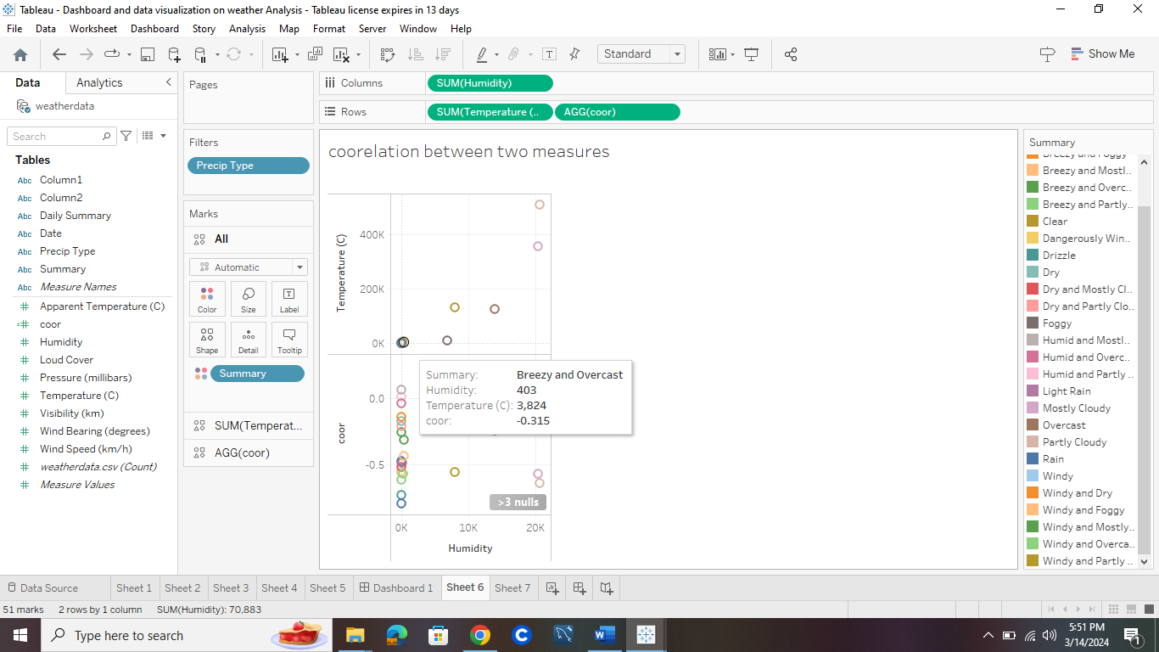

We need to use formula for getting correlation between Temperature and Humidity and formula is coor.

The circles which are appearing in the above picture are used to represent weather conditions and its correlations.

Correlation analysis in Tableau involves examining the relationship between two or more variables to determine if they tend to move in the same direction (positive correlation), move in opposite directions (negative correlation), or have no significant relationship

**Regression Analysis:**

Performing regression analysis in Tableau involves leveraging its statistical capabilities and data visualization features.

We are visualizing the patterns between pressure and wind speed.

The below diagram is representing the regression using pressure with respect to windspeed.

The circles which are appearing are related to precip type and they represents:

Blue represents: Null

Orange represents: rain

Red represents: snow